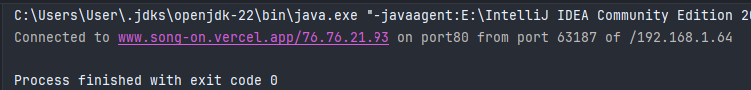

WAP URL Socket Connection

1

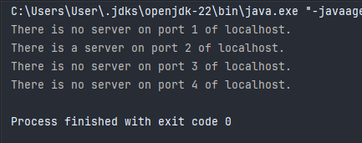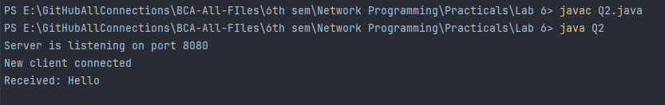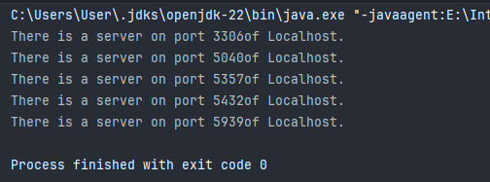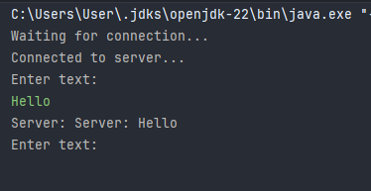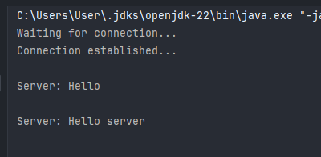

Q5 need to run

Must run Q5

WAp for Socket Creation

.WAP for the higher Port

2

3

WAP low port scanner

4

Q5 is used for Q2 and Q6

Client Socket Connection

5

WAP Server Socket Connection

6

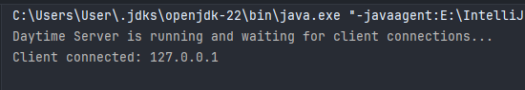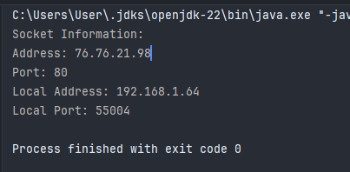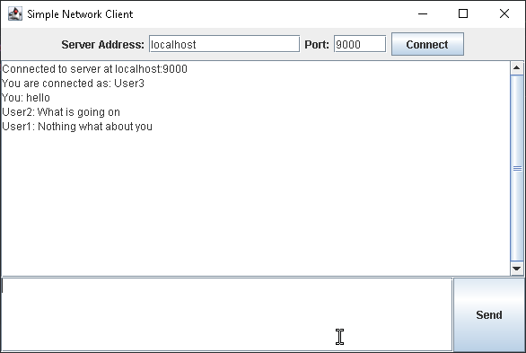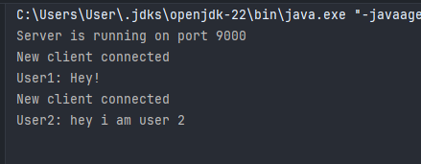

Q5 need to run

• Write a server side program for daytime service using socket.

• Write a program to display the socket information address,port,localaddress,

localportaddress, port, local address, local portaddress,port,localaddress,localport.

8

Simple Network Client GUI

7

Chat Server